**INDIVIDUAL EXERCISES**

**EASY**

1. **ECHO YOUR NAME**

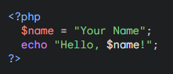

1. **SUM OF TWO NUMBERS**

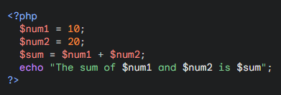

1. **AREA OF TRIANGLE**

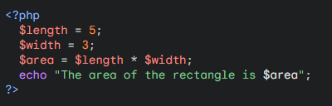

1. **EVEN OR ODD NUMBERS**

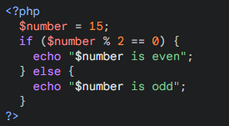

1. **SIMPLE CALCULATOR**

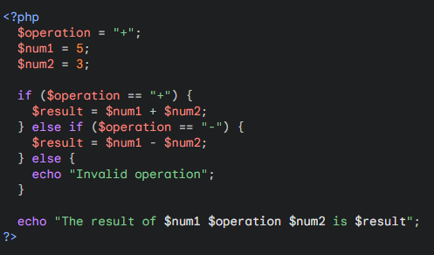

1. **GUESSING GAME**

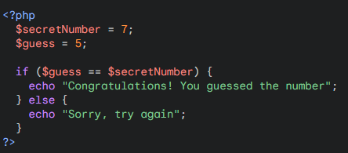

1. **DISPLAYING CURRENT DATE AND TIME**

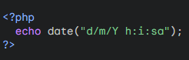

1. **SIMPLE ARRAY EXAMPLE**

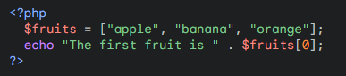

1. **LOOPING THROUGH AN ARRAY**

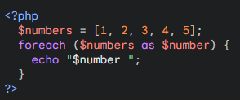

1. **SIMPLE FORM WITH PROCESSING**  
   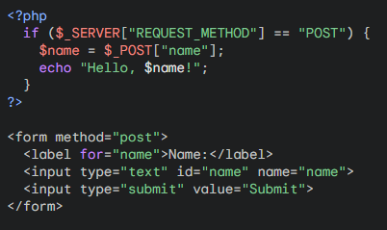

**HARD**

1. **PRIME NUMBER CHECK**

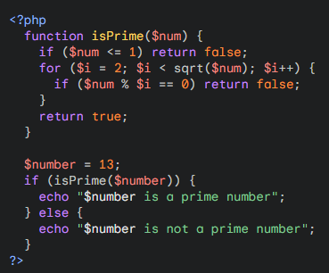

1. **SIMPLE PASSWORD GENERATOR**

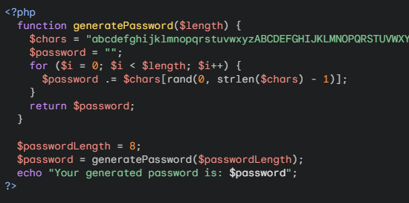

1. **SIMPLE FILE READING AND WRITING**

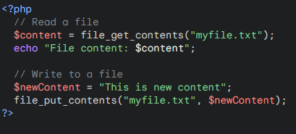

1. **TEMPERATURE CONVERTER**

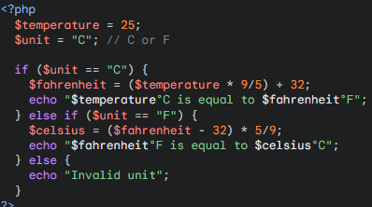

1. **SIMPLE LOGIN SYSTEM (USING SESSION)**

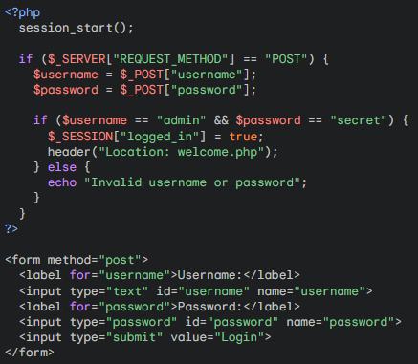

1. **SIMPLE IMAGE UPLOAD**

